DIGITAL ELECTRONICS

**FILTERS AND DENOISING**

ADITYA SINGH 2K19/EP/005

horizontal line

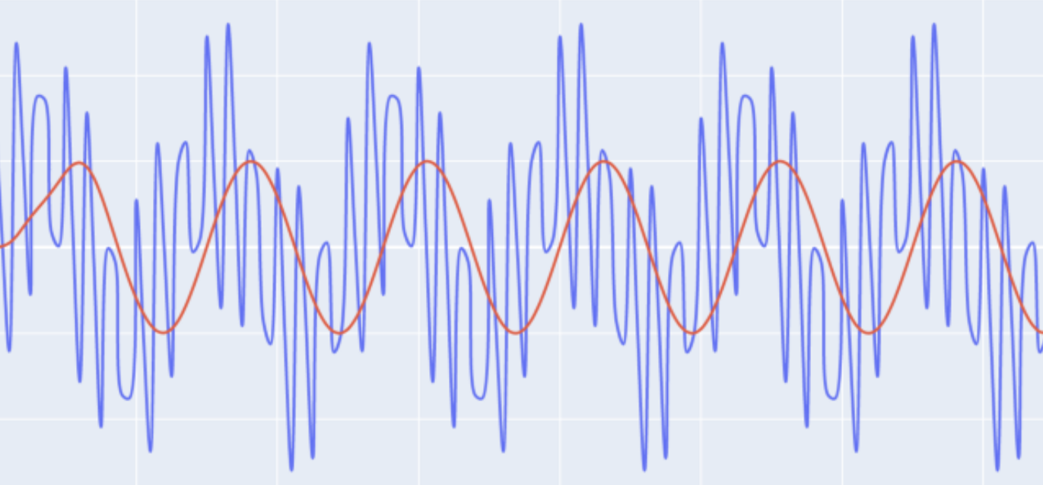

# OBJECTIVE

# To Remove noise from signals using fast fourier transform and different filters.

# INTRODUCTION

A filter is a circuit that removes, or “filters out,” a specified range of frequency components. In other words, it separates the signal’s spectrum into frequency components that will be passed and frequency components that will be blocked.

These filters are made up of passive components such as resistors, capacitors and inductors and have no amplifying elements (transistors, op-amps, etc) so have no signal gain, therefore their output level is always less than the input.

# TYPES OF FILTERS

### 1. Low Pass - low frequencies are passed, high frequencies are attenuated.

2. **High Pass** - high frequencies are passed, low frequencies are attenuated.

3. **Band Pass** - only frequencies in a frequency band are passed.

4. **Band Stop** - only frequencies in a frequency band are attenuated.

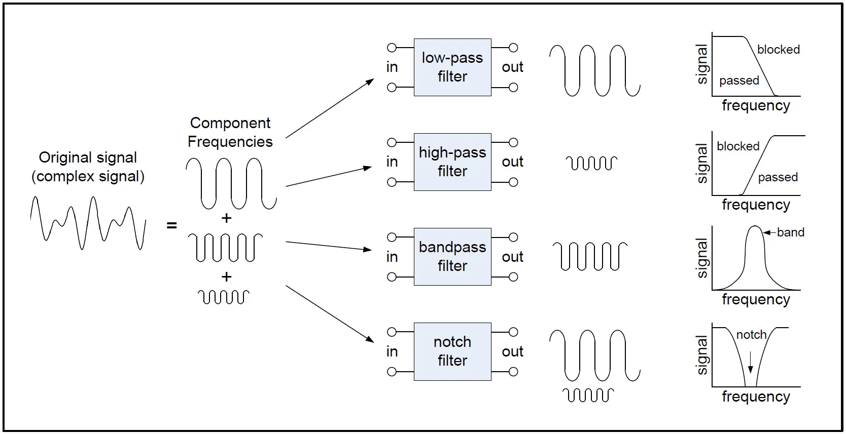

### Passive and Active Filters

Filters can be placed in one of two categories: passive or active.

Passive filters are most responsive to a frequency range from roughly 100 Hz to 300 MHz. The limitation on the lower end is a result of the fact that at low frequencies the inductance or capacitance would have to be quite large. The upper-frequency limit is due to the effect of parasitic capacitances and inductances. Careful design practices can extend the use of passive circuits well into the gigahertz range.

Active filters are capable of dealing with very low frequencies (approaching 0 Hz), and they can provide voltage gain (passive filters cannot). Active filters can be used to design high-order filters without the use of inductors; this is important because inductors are problematic in the context of integrated-circuit manufacturing techniques. However, active filters are less suitable for very-high-frequency applications because of amplifier bandwidth limitations. Radio-frequency circuits must often utilize passive filters.

**RC LOW PASS CIRCUIT**

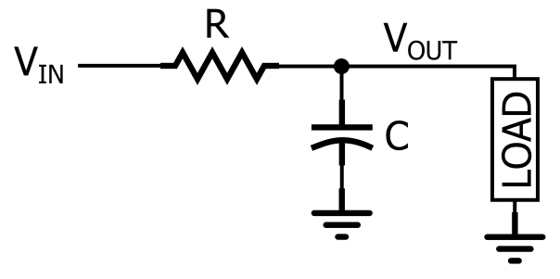

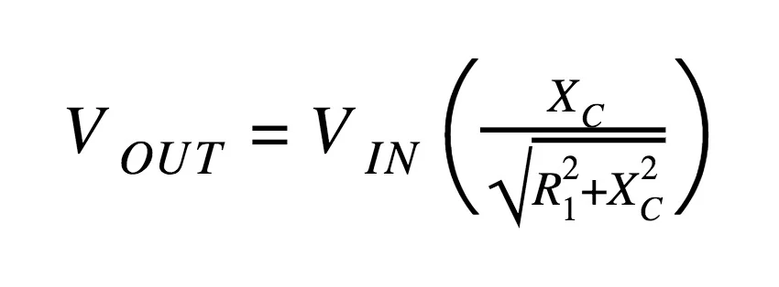

**SIMULATION ON LTSPICE**

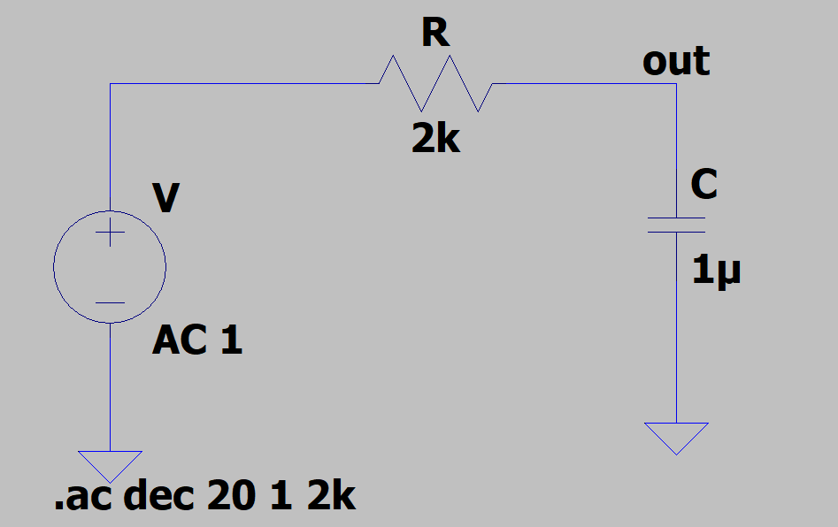

**OUTPUT**

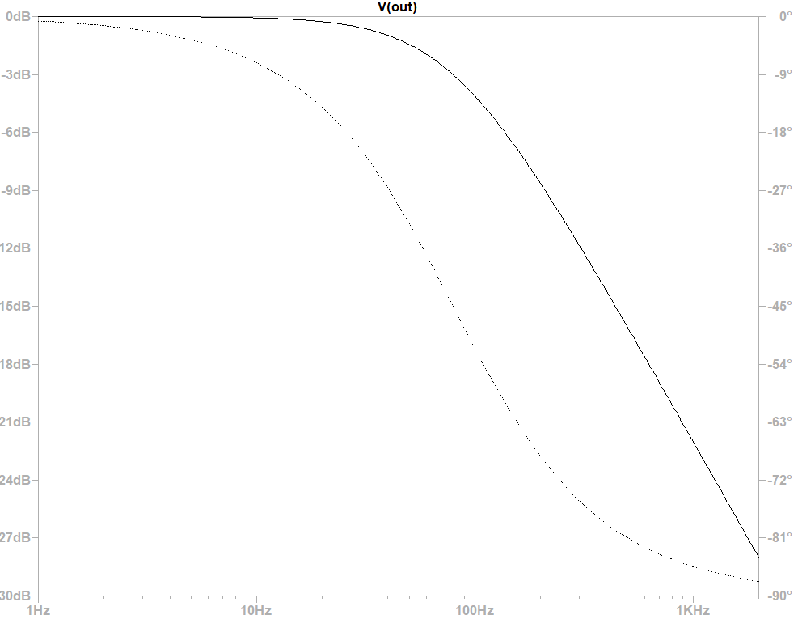

When this occurs the output signal is attenuated to 70.7% of the input signal value or -3dB (20 log (Vout/Vin)) of the input. Although R = Xc, the output is not half of the input signal. This is because it is equal to the vector sum of the two and is therefore 0.707 of the input.

As the filter contains a capacitor, the Phase Angle ( Φ ) of the output signal LAGS behind that of the input and at the -3dB cut-off frequency ( ƒc ) is -45o out of phase. This is due to the time taken to charge the plates of the capacitor as the input voltage changes, resulting in the output voltage (the voltage across the capacitor) “lagging” behind that of the input signal. The higher the input frequency applied to the filter the more the capacitor lags and the circuit becomes more and more “out of phase”.

Similarly we can simulate high and band pass filters with corresponding circuits.

**APPLICATIONS**

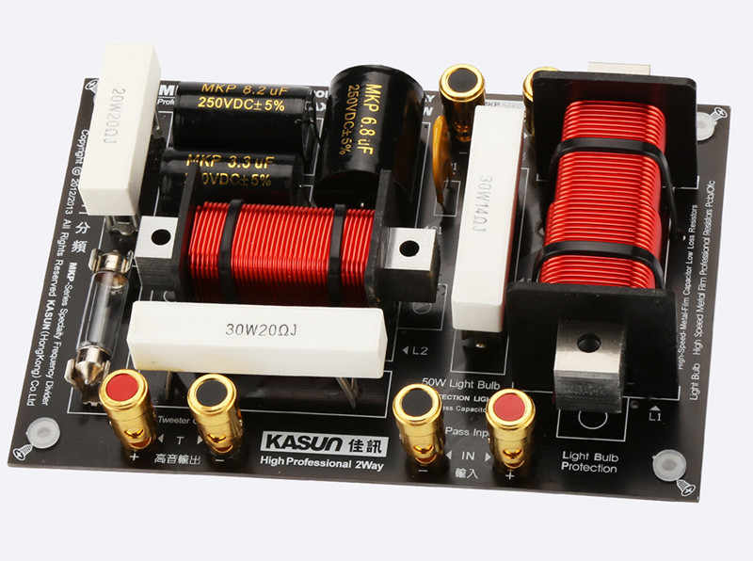

* **The tuner in radio**: The bandpass filter in the tuner of the radio allows a fixed frequency to the output speaker.
* **Treble & bass of the speaker**: The bass has lower frequencies & treble has higher frequencies. They are separated using high pass & low pass filters and are separately routed to corresponding bass speakers & treble speakers for clear music.
* **Anti-Aliasing**: it is a low pass filter that filters out the high-frequency components from a signal before sampling. It prevents the aliasing component from being sampled.
* **Power Supply Smoothing**: The output of the power supply which is a rectifier has an AC ripple in it. These frequencies are filtered out using a low pass filter which results in smoothing the output signal.
* **Noise suppression**: They are used in communication systems for noise removal from the received signals.

**FIR versus IIR**

Two classes of digital filters are Finite Impulse Response (FIR) and Infinite Impulse Response (IIR).

The term ‘Impulse Response’ refers to the appearance of the filter in the time domain. Filters typically have broad frequency responses, which correspond to short duration pulses in the time domain

**NOISE REDUCTION**

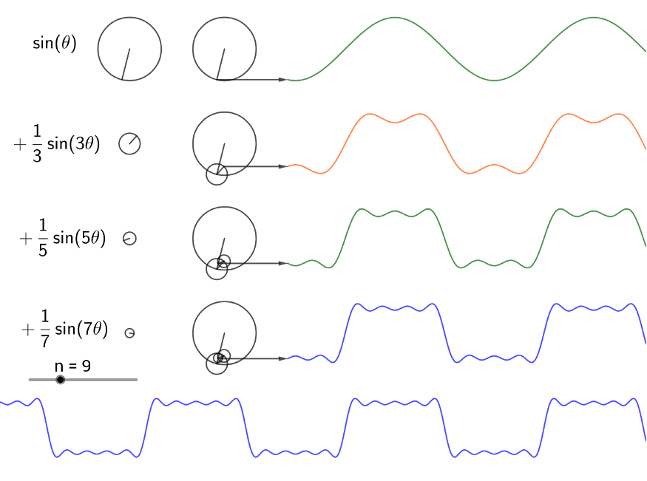

All signal processing devices, both analog and digital, have traits that make them susceptible to noise. Noise can be random or white noise with an even frequency distribution, or frequency-dependent noise introduced by a device's mechanism or signal processing algorithms.

**FAST FOURIER TRANSFORM**

The FFT is a fast, O[NlogN] algorithm to compute the Discrete Fourier Transform (DFT), which naively is an O[N2] computation.

Fourier Transform is used to convert signals from time domain into the frequency domain.

It allows us to:

* Check the signal’s behaviour in the frequency domain.
* Perform some functions in frequency domain.

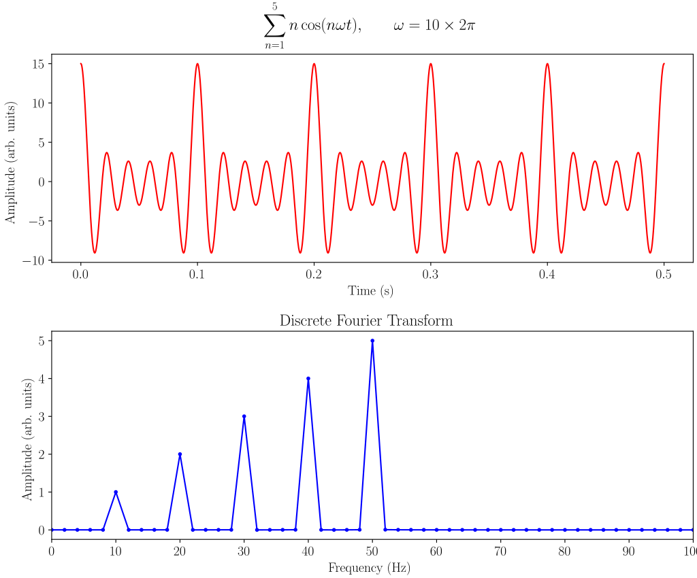

**PYTHON SIMULATION** ([Code Link](https://github.com/adityanjr/Sem-II/blob/master/noise.ipynb))

* Import required python packages - matplotlib, numpy and scipy for computations.
* Generate a signal and add noise to it.
* Take spectral analysis - compute fast fourier transform.
* Apply a filter to remove noise.
* Plot the filtered signal.

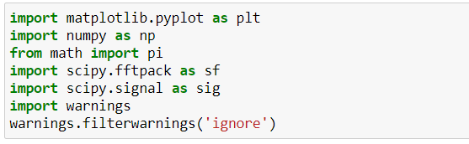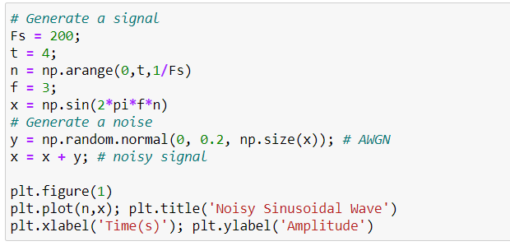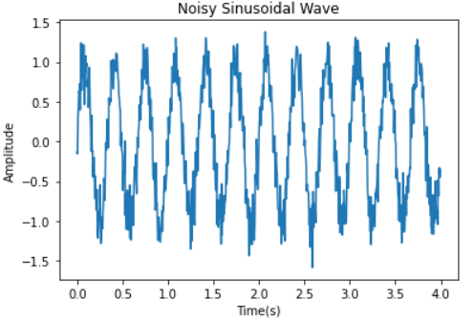

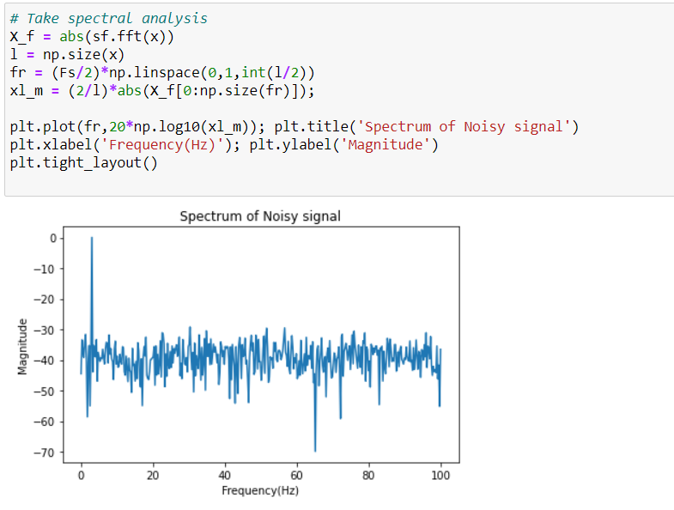

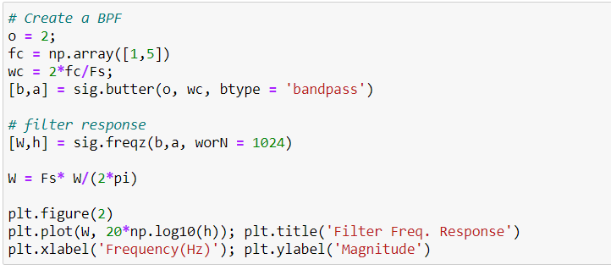

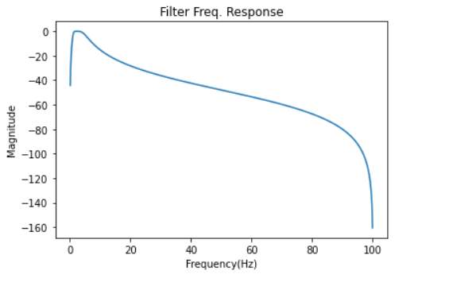

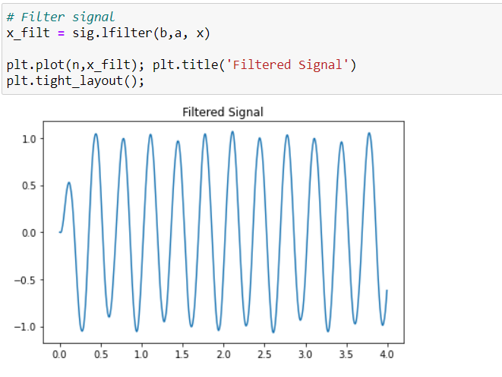

**THANK YOU**